Project structure

| **Date** | 24 November 2022 |
| --- | --- |
| **team id** | | PNT2022TMID37024 | | --- | |
| **Project title** | | AI Powered Nutrition Analyst for Fitness Enthusiasts | | --- | |

**Project Structure**

Create a Project folder that contains files as shown below

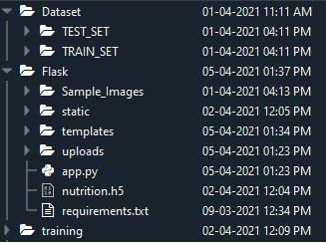

• Dataset folder contains the training and testing images for training our model.

• We are building a Flask Application that needs HTML pages stored in the templates folder and a python script app.py for serverside scripting

• we need the model which is saved and the saved model in this content is a nutrition.h5

• templates folder contains home.html, image.html, imageprediction.html pages.

• Statis folder had the css and js files which are necessary for styling the html page and for executing the actions.

• Uploads folder will have the uploaded images(which are already tested).

• Sample_images will have the images which are used to test or upload.

• Training folder contains the trained model file.